THE NURSERY SCHOOL
AT SAINT JAMES THE LESS
2’s Program
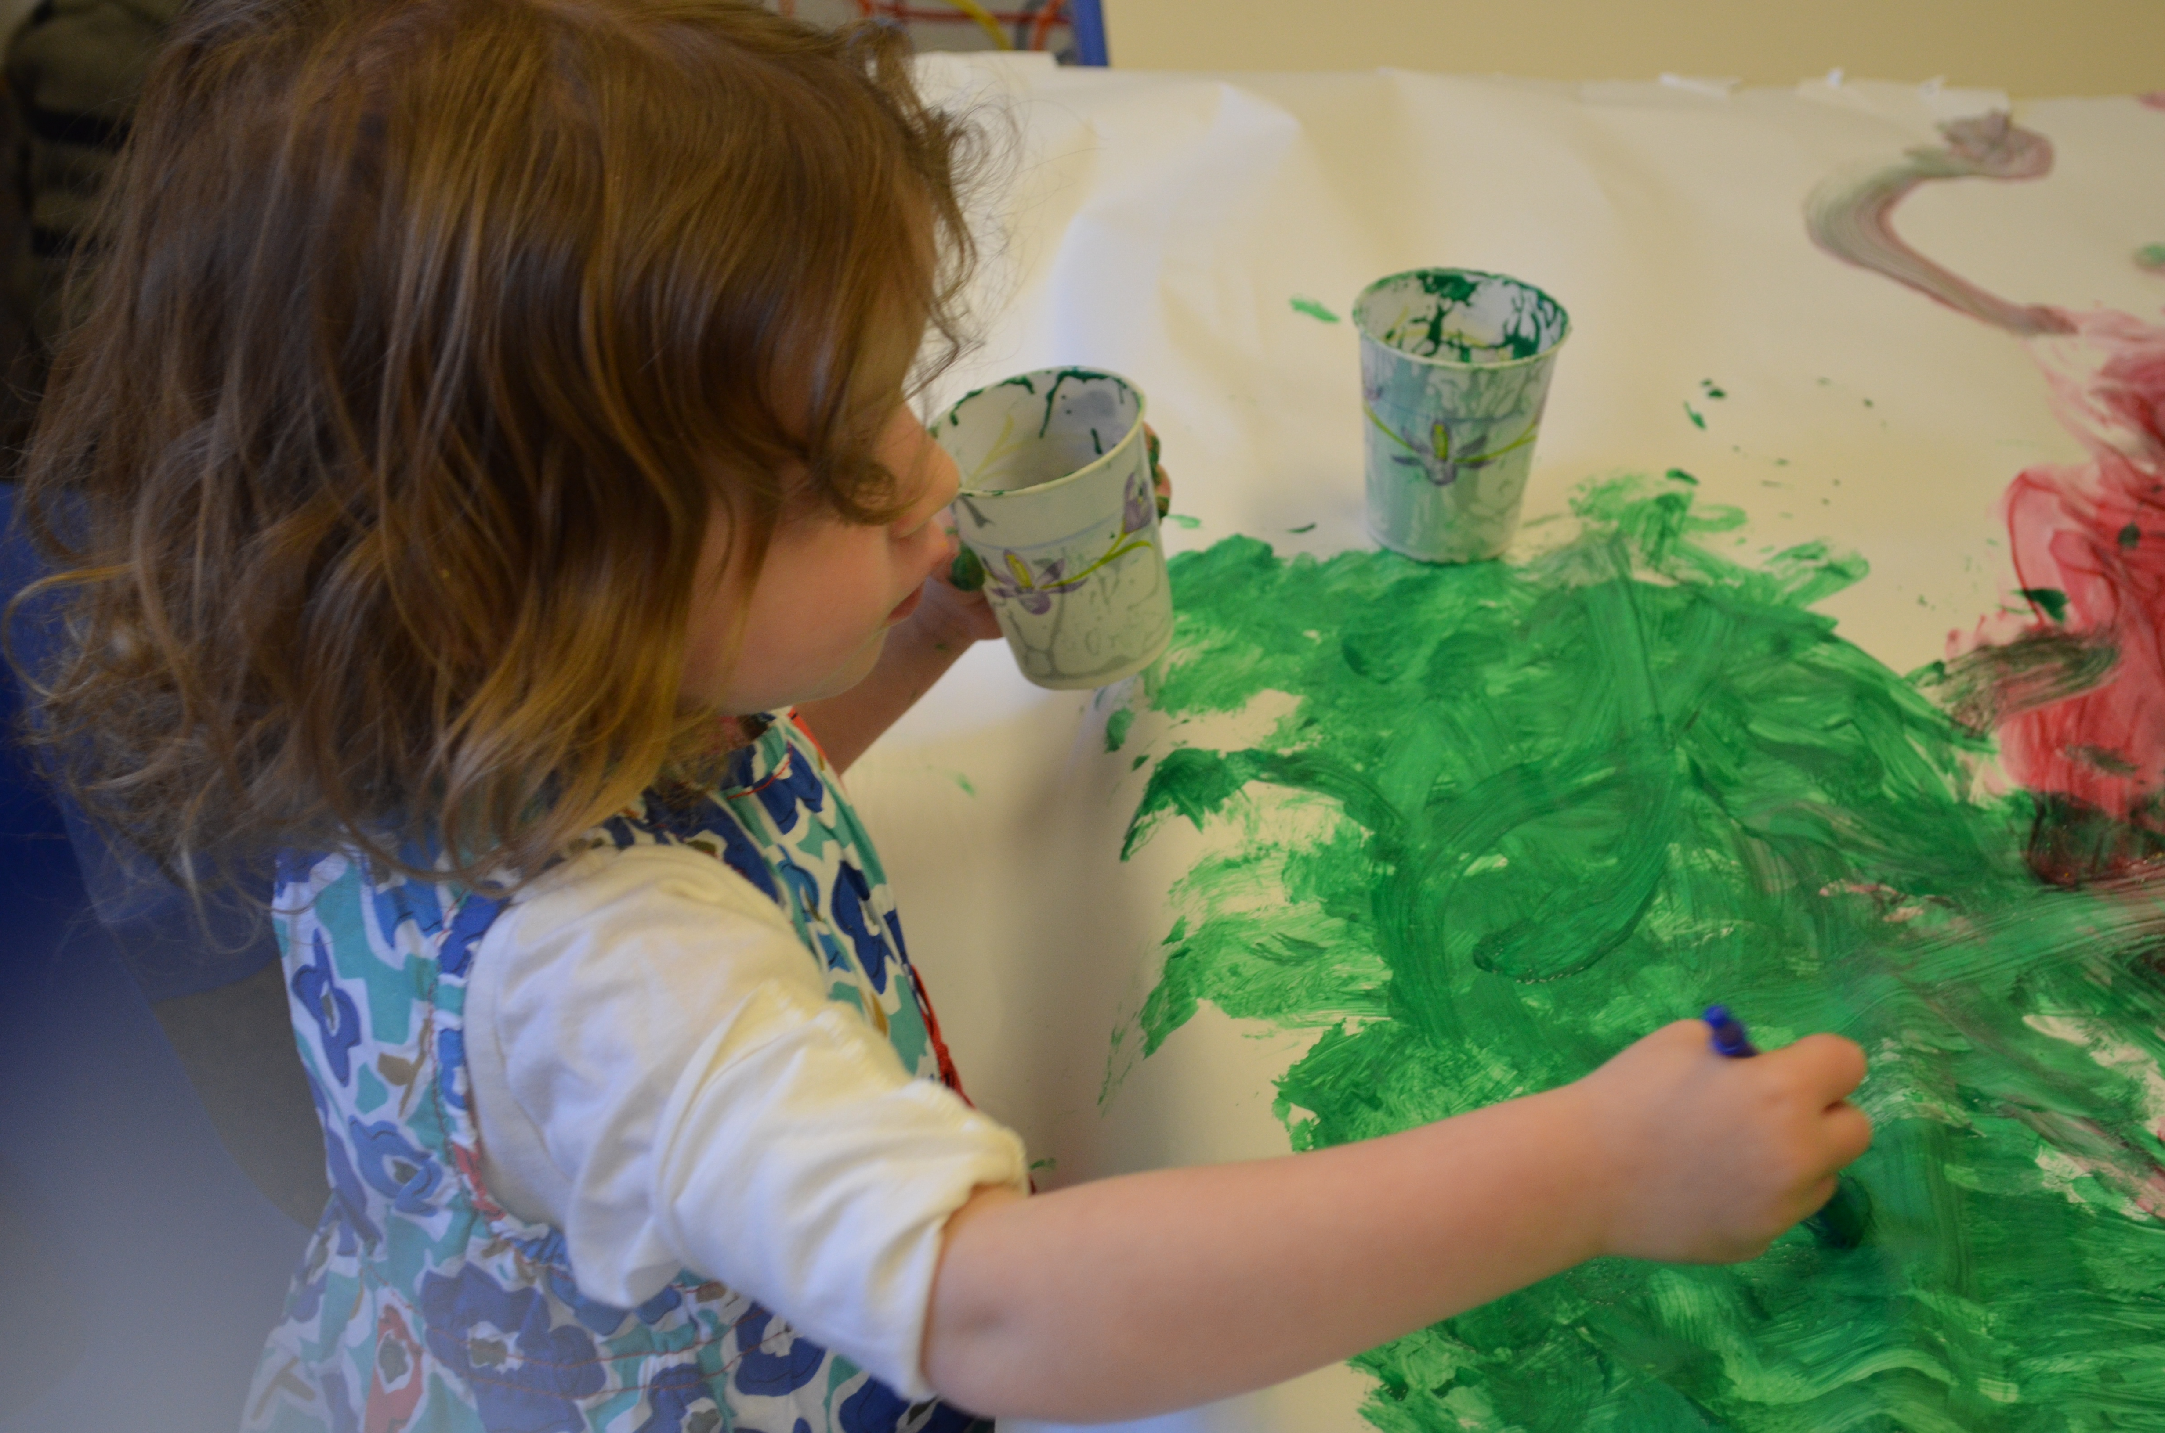

School for the 2’s begins in Early September as a Phase-in process. During Phase-in, half the class comes to school from 9:00 -10:00. The second half comes 10:30 -11:30. Phase-in usually lasts for 2-3 weeks and the first full day of school for the whole class is in late September.

An Average Day in the 2’ class:

9:00- 9:45: Free Play Time- Fostering Language, Social Interaction, Fine Motor Skills
9:45-10:05: Circle Time: Welcome Friends
Morning Songs, Group Activity
Discuss/Demonstrate Art Project

10:05-10:20: Art Project : Small/Large Groups

10:20-10:50: Hand Washing/Snack/ Story Time/
Music

10:50-11:30/45 Playground/Indoor Gross Motor Skills
11:30 Dismissal Sept. - Dec.
11:45 Dismissal Jan. - May


Music and Movement with Specialists on Tuesdays and Wednesdays

