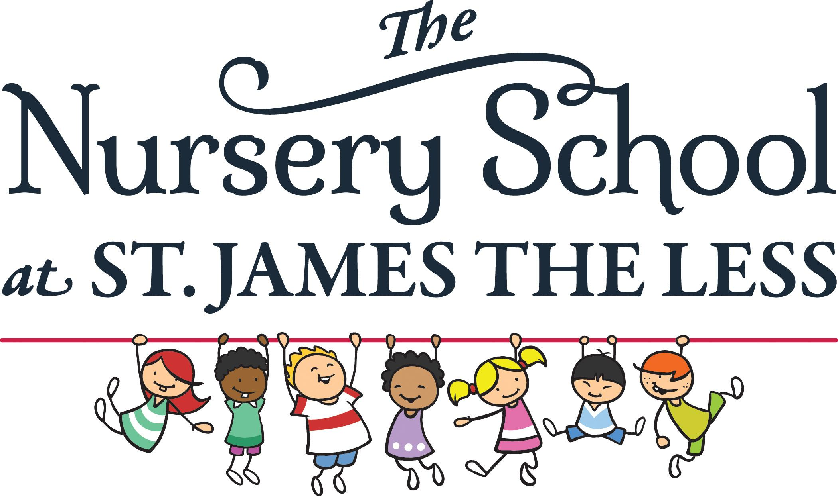
Dear Parent,
Throughout the year we take pictures and videos of the children as one of the ways for you to see what your child is doing as well as for teachers to document what the children are doing.
These pictures will also be used at our annual end of year ceremony. We may also want to use some of these pictures in our brochure and on our website as well as our closed Facebook page. Please fill out the permission form below and return it to your child’s teacher as soon as possible.
Thank You.

__________ Yes, I give The Nursery School at St James the Less permission to use
images of my child __________________________________

__________ No, I do not give The Nursery School at St James the Less permission to
use images of my child ______________________________

Signature Date

_____________________ ____________

